|  |  |
| --- | --- |
| Umrechnungsfaktor Brennwert Hackschnitzel | 08/2024 |
|  | |

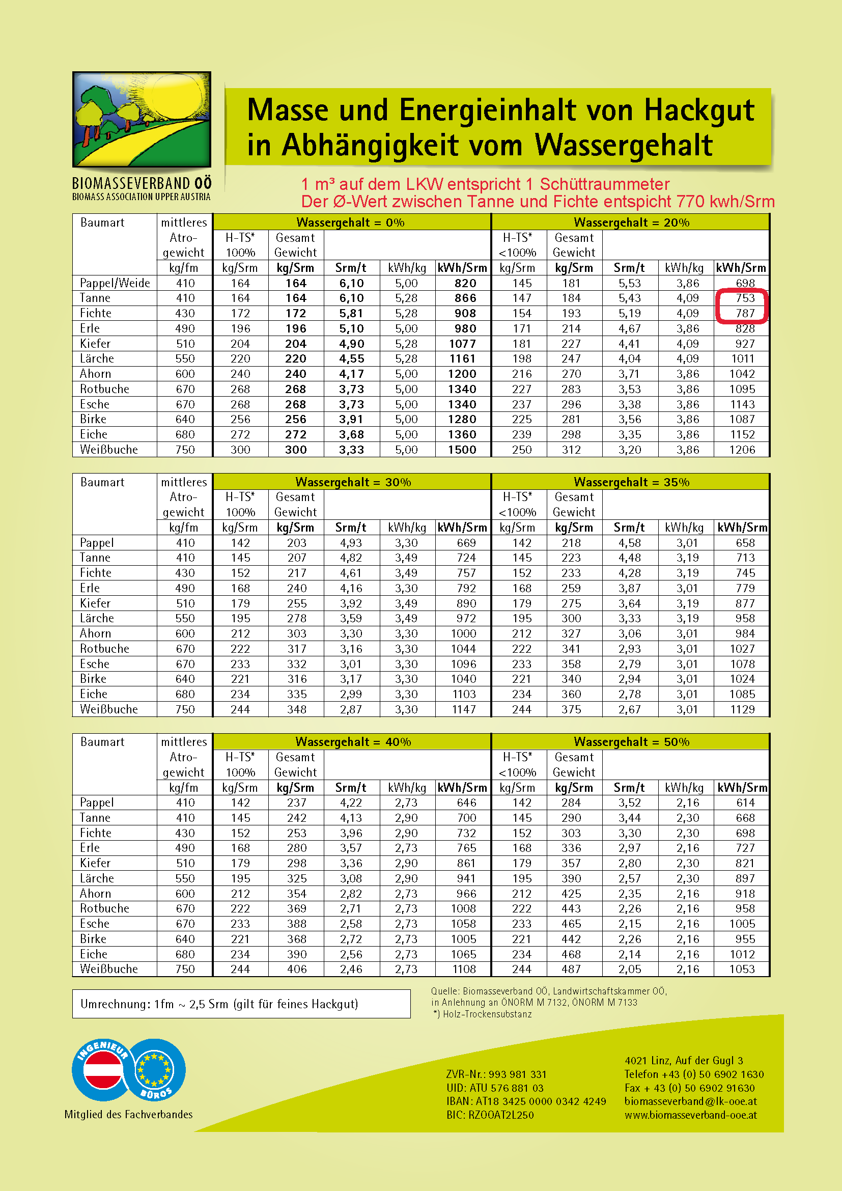

**1.540 (Summe)  
2  
= 770 kWh/m³**

|  |
| --- |
|  |

